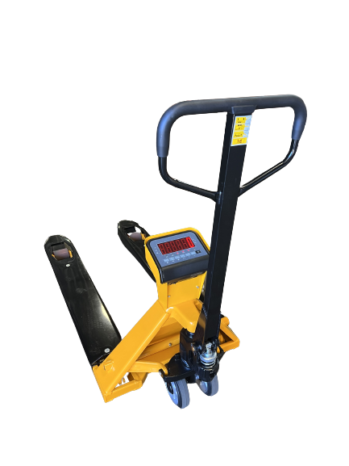

* **Robust construction**
* **Advanced mobile weighing functionality**
* **Fast delivery times**
* **0.1% of the load lifted**
* **Built-in 7.4Vdc/4Ah rechargeable Li-ion battery**
* **Printer optionally available**

**The HPT-X is a robust, basic hand pallet truck with integrated weighing system that brings mobile weighing of palletized goods in logistic warehouses or production sites a step closer.**

Checking weights of incoming goods? Determine accurate shipping weights? Optimize your internal transport by saving time, space and costs with the HPT-X, the smart choice in mobile weighing.

**General Dimensions (in inch)**

|  |  |  |
| --- | --- | --- |
| A | Fork length | 48” |
| B | Fork width | 7.1” |
| C | Fork height (min) | 3.25” |
| D | Fork height (max) | 7.9” |
|  | Lifting height | 4.8” |
| E | Width over forks | 27.2” |
| F | Height upper side | +/-32.5” |

Capacity 5,000 lb

Graduation 1 lb

Accuracy 0.1% of the load lifted

Display LED, height 1.8”

Keypad 6 functions keys, standby on/off

on/off switch

Protection class loadcells and wiring IP67,

indicator IP65

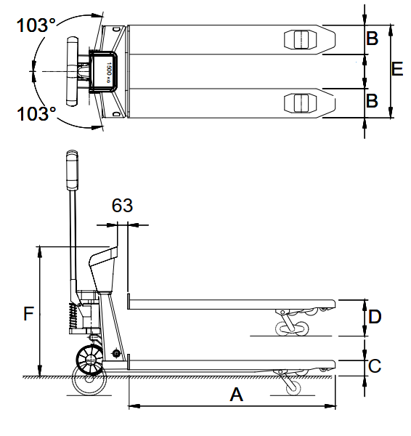Battery 7.4VDC/4Ah Li-ion

Charger 110 Volt

Autonomy 30 hours, low battery indication

Steering wheels rubber

Load wheels polyurethane, tandem

Colour yellow/black, epoxy painted

Weight 235 lb

**Standard functions**

* Automatic and manual zero correction
* Gross/net weighing (tare)
* Totaling with sequence number
* On/off switch
* Auto shut-off
* Piece counting



