Publication date: 19 January 2026

RAVAS presents: The best weighing system for forklift trucks!
The RAVAS iCP Performance is a robust and accurate mobile weighing solution for forklift trucks, designed for intensive use in demanding logistics environments. This fully automatic weighing system enables weighing while driving and combines speed, reliability and efficiency. The iCP Performance is ideal for companies that handle large numbers of pallets and require stable and accurate registration of gross weight.
The RAVAS iCP Performance is OIML-compliant (certification pending, expected Q1 2026) and offers unrivalled efficiency for applications in LTL transport and air freight, among others, where every second counts. Thanks to the fully automated weighing function, no time is lost due to downtime and human errors are prevented.
Revolutionary design (patent pending)
The iCP Performance is built on RAVAS' new RedBox platform and features a completely newly developed indicator. The iCP Performance also features a latest-generation mechanical design, with four 2D load cells, low dead weight and maximum visibility for the driver. This system is not only robust and reliable, but also extremely user-friendly in intensive logistics environments.
Efficient, accurate and future-proof
The system delivers highly accurate measurements under all working conditions and integrates seamlessly with existing WMS, TMS and ERP systems. In addition, the iCP Performance is equipped with built-in safety features and designed with future digitisation and automation in mind.
With the optional Weigh in Motion technology, integrated fork positioner and side shifter, pallets can be placed faster and more safely, with minimal impact on the truck's lifting capacity.
The main advantages at a glance:
- Fully automatic weighing while driving – no time loss, no errors
- Revolutionary mechanical design – low weight, so minimal impact on truck capacity; maximum visibility
- Highly accurate and OIML-compliant – Best in class in the market: capacity 2500 kg, in 1 kg increments, calibration possible
- Seamless data integration – direct link to WMS, TMS or ERP business software
- Built-in safety – load centre of gravity display; visual and audible warning in case of overload or tipping hazard.
- Future-proof – Over-the-air updates with new functionalities, via free Indicator App. The system grows with the customer over time.
- Optional integrated fork positioner & side shifter – faster pallet management with minimal impact on truck capacity
- Uniform – Fits any forklift truck; can be used on both new and existing trucks.
The RAVAS iCP Performance makes weighing with forklift trucks safer, smarter and more efficient. Companies save time and money by automatically checking transport weights without interrupting the workflow.
Discover the best mobile weighing solution in its class and find out how the RAVAS iCP Performance can transform your logistics processes. Seeing is believing? Watch our product video!
About RAVAS
RAVAS, founded in the 1970s in Zaltbommel, the Netherlands, has grown to become a global market leader in mobile weighing solutions. The company integrates weighing and measuring technology into a wide range of logistics equipment, such as hand pallet trucks, warehouse trucks, stackers and forklift trucks. By generating real-time data on material flows, RAVAS helps companies optimise their supply chains and operate more efficiently.
RAVAS has offices in eight European countries and the United States, and works with a network of professional partners worldwide. With a team of experts, RAVAS continues to invest in innovation, data integration and smart solutions that contribute to a safer, faster and more data-driven logistics future.
For more information about the RAVAS iCP Performance and other RAVAS solutions, visit www.ravas.com.

Afbeeldingen: 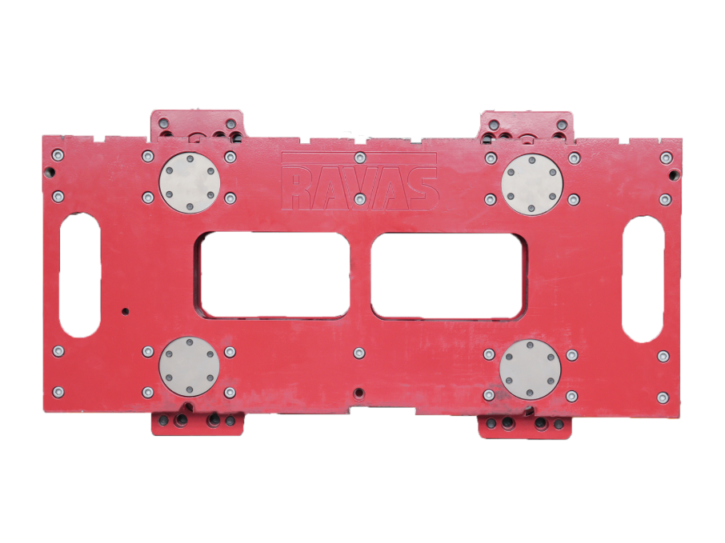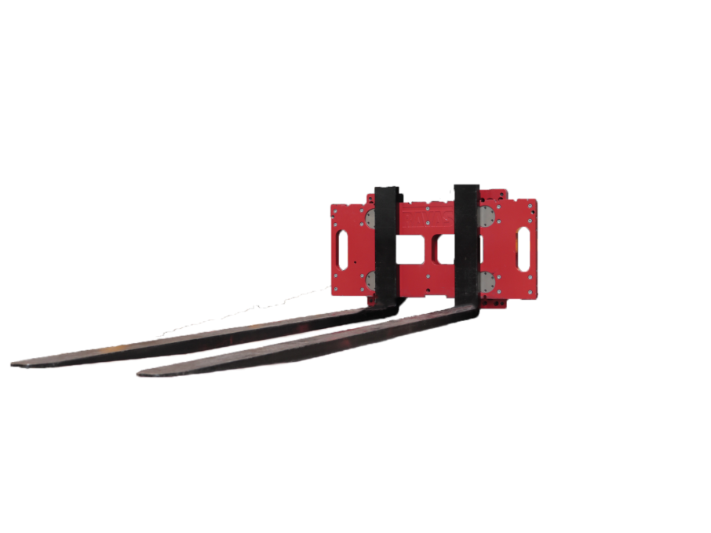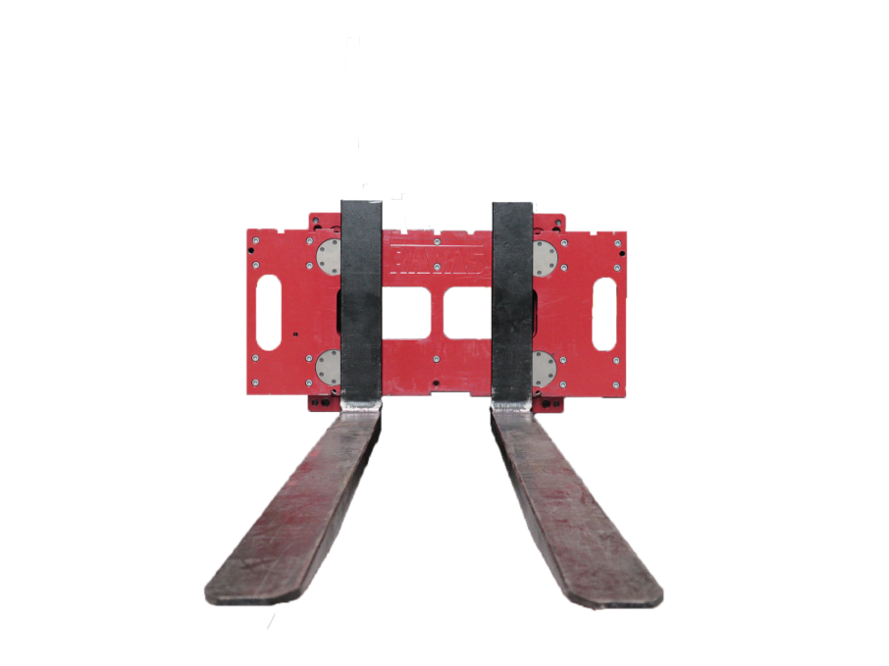
Download portal: ravas.com/download-portal

