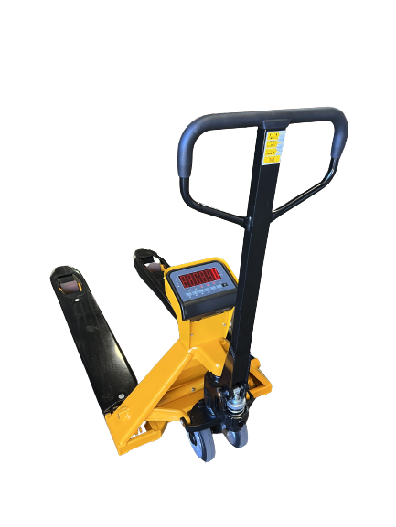
- Robust construction
- Advanced mobile weighing functionality
- Fast delivery times
- 0.1% of the load lifted
- Built-in 7.4Vdc/4Ah rechargeable Li-ion battery
- Printer optionally available

The HPT-X is a robust, basic hand pallet truck with integrated weighing system that brings mobile weighing of palletized goods in logistic warehouses or production sites a step closer.

Checking weights of incoming goods? Determine accurate shipping weights? Optimize your internal transport by saving time, space and costs with the HPT-X, the smart choice in mobile weighing.

General Dimensions (in inch)
A | Fork length | 48”
B | Fork width | 7.1”
C | Fork height (min) | 3.25”
D | Fork height (max) | 7.9”
 | Lifting height | 4.8”
E | Width over forks | 27.2”
F | Height upper side | ⁺/₋32.5”
Capacity 5,000 lb
Graduation 1 lb
Accuracy 0.1% of the load lifted
Display LED, height 1.8”
Keypad 6 functions keys, standby on/off
on/off switch
Protection class loadcells and wiring IP67,
indicator IP65
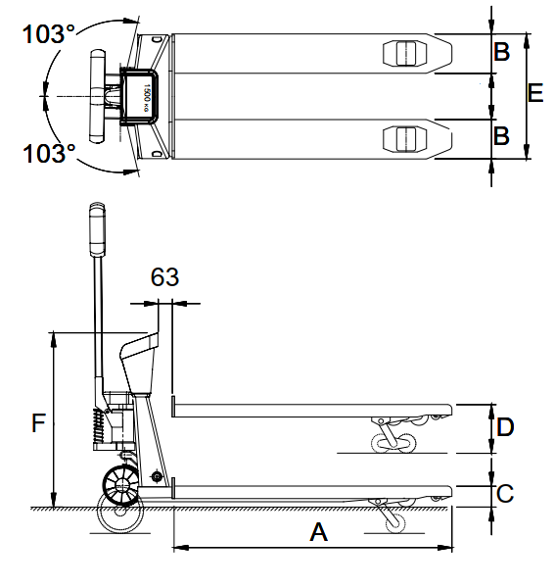
Battery 7.4VDC/4Ah Li-ion
Charger 110 Volt
Autonomy 30 hours, low battery indication
Steering wheels rubber
Load wheels polyurethane, tandem
Colour yellow/black, epoxy painted
Weight 235 lb

Standard functions
- Automatic and manual zero correction
- Gross/net weighing (tare)
- Totaling with sequence number
- On/off switch
- Auto shut-off
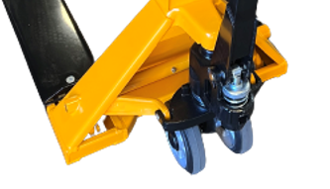
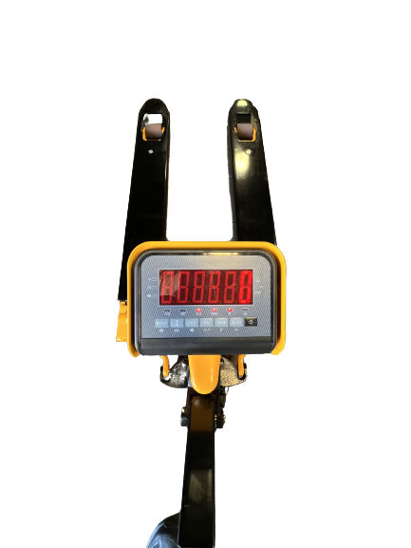
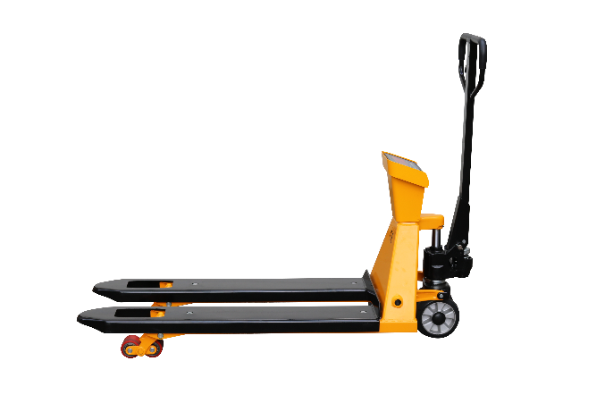
- Piece counting

